Developing a Student Information System (SIS) Using Product Breakdown Structure (PBS)

1. Objectives
The main objectives of developing the Student Information System (SIS) are:
- To centralize student information management in a single system.
- To automate academic and administrative processes.
- To improve the accuracy and security of student data.
- To facilitate efficient course enrollment, attendance tracking, and grade management.
- To provide timely and accurate reports for students, faculty, and administrators.
- To enhance communication and information accessibility within the institution.

2. Major Components of the Student Information System
The proposed Student Information System (SIS) consists of the following major components:
- Student Registration Management
- Academic Records Management
- Course Enrollment Management
- Attendance Management
- Grade Management
- Reporting and Analytics
- User Management and Security

3. Product Breakdown Structure (PBS)

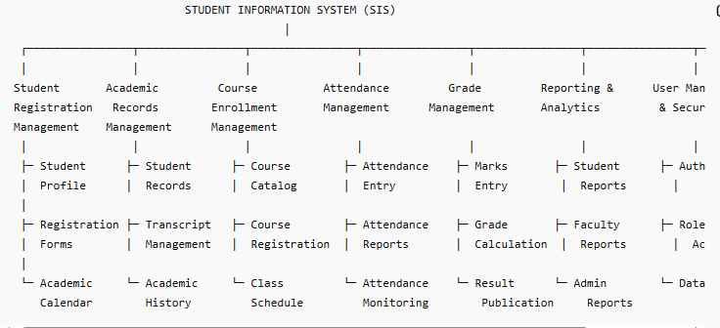

4. Dependency Analysis
The components of the Student Information System are interconnected.
- Student Registration Management must be completed before Course Enrollment.
- Course Enrollment Management depends on student registration data.
- Attendance Management requires course enrollment information.
- Grade Management depends on attendance records and enrolled courses.
- Academic Records Management stores and maintains the results generated by the Grade Management module.
- Reporting and Analytics collects data from all modules to generate reports.
- User Management and Security supports all modules by controlling access and ensuring data protection.

External Dependencies
The SIS may integrate with:
- Learning Management System (LMS)
- Library Management System
- Payment Gateway
- Email and SMS Services
- Institutional Student Information System (SISI)

5. Proposed Integration Points

Learning Management System (LMS)
Integration with LMS allows synchronization of course materials, assignments, and learning activities.

Library Management System
Students can access library services using the same institutional account.

Payment Gateway
Supports online payment of tuition fees and other academic charges.

Email and SMS Services
Provides notifications regarding registration, attendance, examination results, and important announcements.

Institutional Student Information System (SISI)
Allows secure data exchange between the departmental SIS and the institution-wide information system.

6. Additional Features
The following features may further enhance the system:
- Mobile Application Support
- Online Advising System
- Student Performance Dashboard
- Automated Notifications

- Real-Time Analytics
- Role-Based Access Control

7. Conclusion
The proposed Student Information System (SIS) provides a centralized platform for managing student information, academic records, attendance, grades, and course enrollment. The Product Breakdown Structure (PBS) helps identify all major system components and their sub-components, ensuring a systematic development process. The system improves efficiency, accuracy, and accessibility while supporting future integration with other institutional systems.

